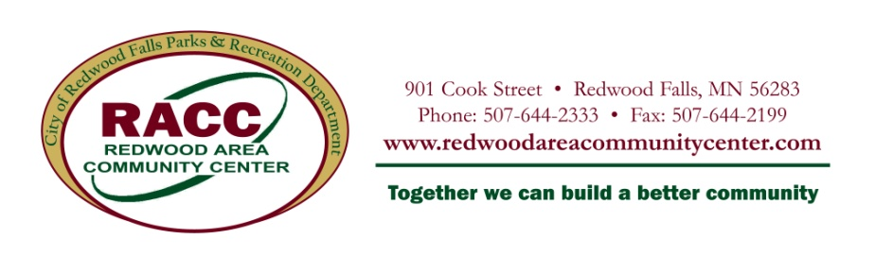
Westside/Perks Park Playground RFP
The City of Redwood Falls is requesting proposals to design, supply new equipment and install a neighborhood park playground. The total budget for this project is $84,000. Proposals must include all related expenses from design, securing permits, constructing, installing, delivery and sales tax if applicable. The City of Redwood Falls will be responsible for removing and disposing of the existing equipment.
RFP’s will be accepted from the following vendors:
- Vendors listed on the State of Minnesota Contract
- Vendors listed on the U.S. Communities Contract
Selection criteria will include: play value, layout and design, overall impression, quality of equipment, innovation, color, safety/risk management, maintenance, and warranty.
The concept plan for the park is contained within this RFP.
The playground must be completed by September 15, 2014 with final inspection by October 1, 2014. The project start date will begin after Monday, June 23, 2014.
Name | Westside Park (Container 1)
Location | 320 West Bridge Street, Redwood Falls MN 56283
Misc. | Very close in proximity to Perks Park, this playground is near the softball field. We are looking for a playground to entertain children ages 2-5 while their siblings and/or parents are playing softball. This playground would allow that age group the freedom of play and parents are still able to watch the game.
General Information:

Name | Perks Park (Container 2)
Location | 320 West Bridge Street, Redwood Falls MN 56283
Misc. | This neighborhood park serves the western neighborhoods of Redwood Falls and includes a lighted softball field, picnic shelter area, playground equipment, and a fishing pier on scenic Lake Redwood.
Characteristics of Neighborhood:
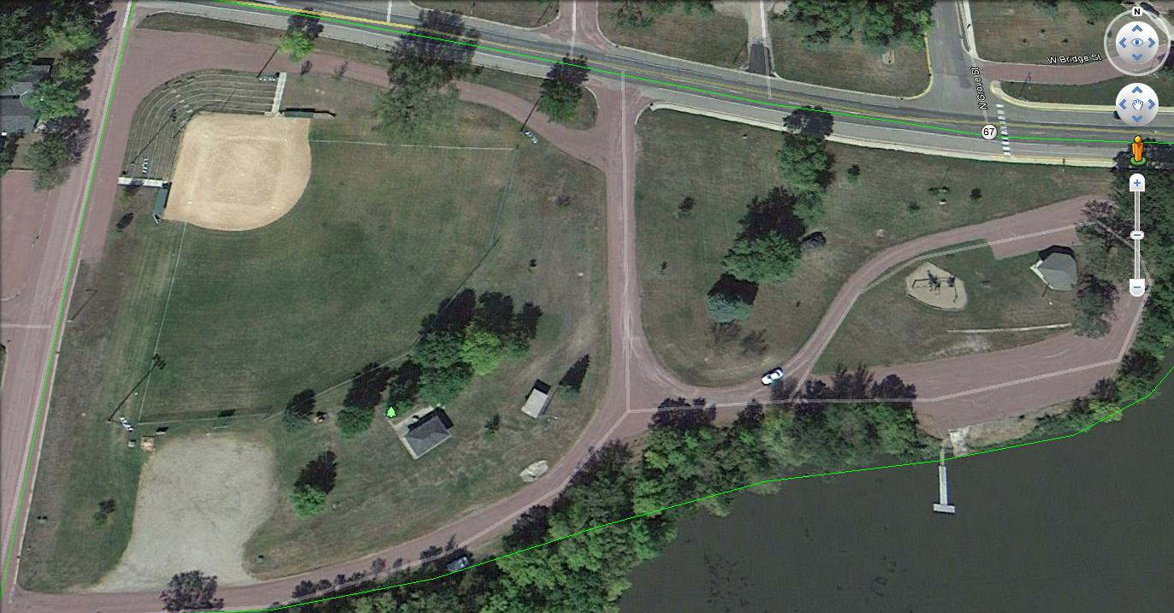
Westside Park
Perks Park

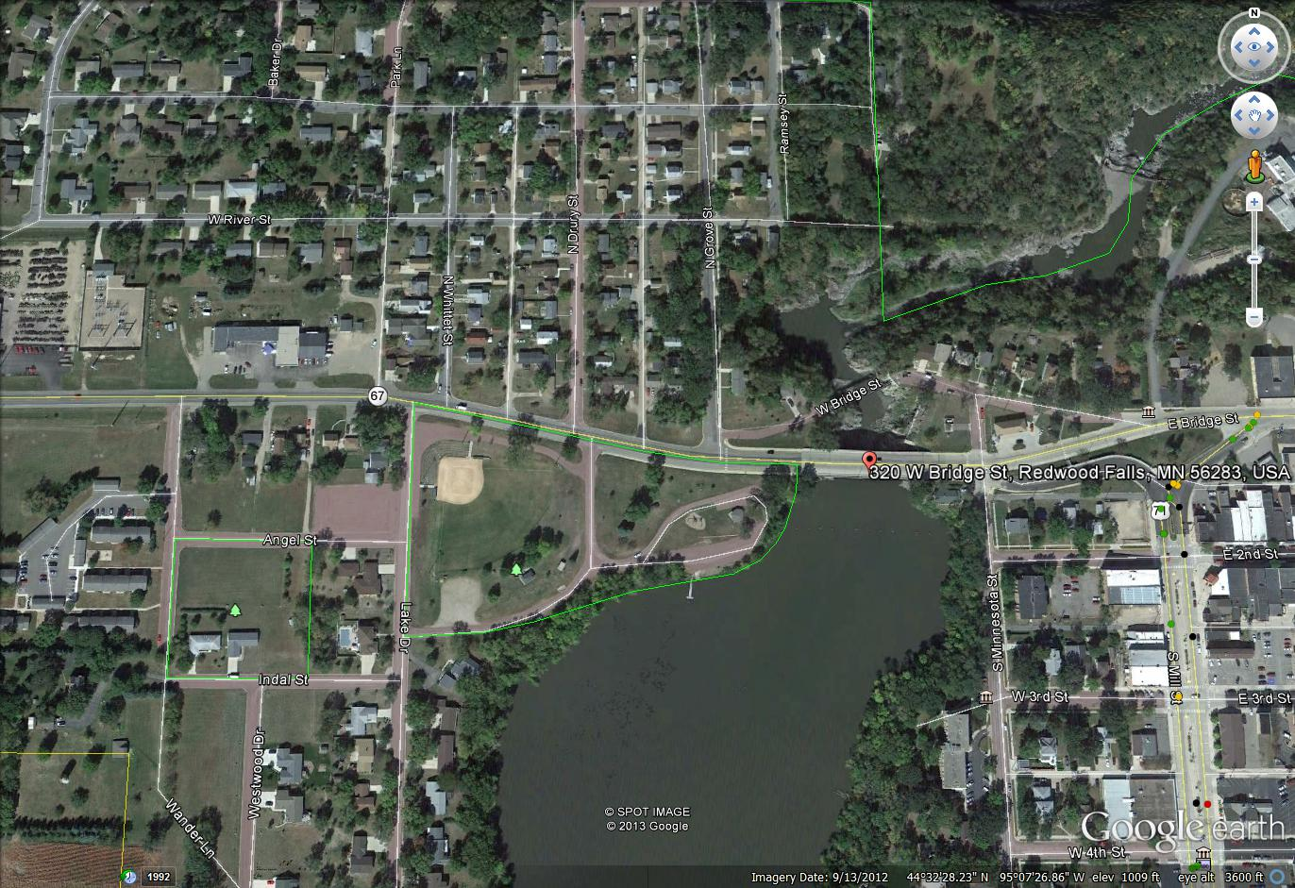

Resident Comments:
*The park should grow with the children and appeal to them as they grow in the neighborhood and community
*The park should be aesthetically pleasing
*Lots of climbing and slides and swings
*Natural design and colors
*The park should attract visitors when they arrive to Redwood Falls (as it is located on the west edge of town)

Playground Structure Specifications:
General Information | One Container which includes ages 2-5 structure; Another container which includes ages 2-12 structure.
Proposal 1:
$84,000 Budget for both containers and alternate
 | Design, Install, Freight and Tax (if applicable)
Container 1 (Westside Park) Size: 40’x40’

Container 2 (Perks Park) Size: 72x46’

 | Stand alone features (required listed below, but open to other suggestions as well)
 | Age appropriate safety signage
Container 1 (Westside Park): Ages 2-5 Year Old Play Area | 1 smaller playground structure
 | Natural Colors – colors to be selected by City
 | Surfacing and edging to be provided and installed by the City
Container 2 (Perks Park): Ages 2-12 Year Old Play Area | 1 playground structure for ages 2-12 (different from container 1)
 | Natural Colors – colors to be selected by City
 | Climbing
 | Swings - minimum of one tot, one handicap, and one seat
 | Surfacing and edging to be provided and installed by the City
 | Roller Slides on Structure (at least 1) 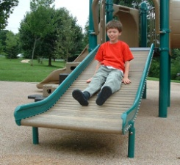
Oodle Swing (1)
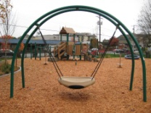
 | Maypole or Something Similar 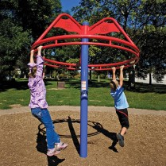

Play Structure Proposal:
- All products meet or exceed ASTM F1487-11 and IPEMA Standards.
- Vendors may submit only one play structure design per container.
- The vendor should include details, photographs or other information which will support the evaluation process. Each component of the proposal shall be listed and priced separately with the aggregate total and discounts if any indicated. Freight and sales tax (if applicable) shall also be itemized.

1 | Container 1 (Westside Park): Ages 2-5 Year Old Play Area | $
2 | Container 2 (Perks Park): Ages 2-12 Year Old Play Area | $
3 | Swings, Stand Alone, Signage, Etc. | $
4 | Installation | $
5 | Freight/Sales Tax (If applicable) | $
Grand Total |  | $

RFP Information – Westside/Perks Park

RFP Due Date: | April 30, 2014
Sealed Proposal To: | Westside/Perks Park Playground  Equipment & Installation  City of Redwood Falls  333. S. Washington St., P.O. Box 526  Redwood Falls, MN 56283

RFP Questions
Contact | Jackie Edwards  Parks & Recreation Director  901 Cook Street  Redwood Falls MN 56283  edwardsj@ci.redwood-falls.mn.us  507-644-2333

Vendor Information

Vendor Name
Product Line
Contact
Address
City |  | State, Zip
Phone
Email

- Bid bond of 10% of the bid amount is due upon bid submission.
- Vendors must complete the responsible bidder information contained within the RFP.
- The City of Redwood Falls reserves the right to reject all RFP’s or parts of the RFP’s and to waive any informalities therein and to accept the RFP’s which is the best interest of the City of Redwood Falls as determined by City Council.
- Delivery and storage of all the material is the responsibility of the vendor. (Delivery will not be accepted before Monday, June 23, 2014.)
- The City will not be responsible for unloading, transportation, storage, vandalism, or loss of any of the above mentioned items.

SIGNED CONTRACT REQUIREMENTS
PERFORMANCE BOND – Will be required as a condition of a signed contract
INSURANCE REQUIREMENTS
Commercial General Liability Insurance Policy with minimum limits of $1,500,000 combined single limit (CSL), with coverage pertaining to premises operations. In the event Combined Single Limits Coverage is not secured by the contractor, the following minimum limits apply:
      - $1,500,000 Aggregate
      - $1,500,000 Products and Completed Operations Aggregate
      - $1,500,000 Personal Injury and Advertising Injury
      - $1,500,000 Each Occurrence
      - $ 100,000 Fire Damage Limit
      - $ 5,000 Medical Expense
  - The policy should be written on an “occurrence” basis and not a “claims-made” basis.
- Automobile Liability Insurance including owned, non-owned, and hired vehicles in an amount not less than $1,500,000 combined single limit (CSL) for total bodily injuries and/or damages arising from any one accident. If automobiles are not used, City must receive a letter from Contractor stating this.
- Professional Liability Insurance (when required) in the minimum amount of $1,500,000 combined single limit (CSL). In the event Combined Single Limits Coverage is not secured by the Contractor, the following minimum limits apply:
      - $1,500,000 Aggregate
      - $1,500,000 per Wrongful Act or Occurrence
- Excess Umbrella Liability Policy in the amount of $1,500,000 will be additionally required if any of the above policies have lower limits than stated.
- Worker’s Compensation Insurance.
- Upon submission of a proposal, and as a condition precedent, the Contractor will furnish the City with an original Certificate of Insurance listing the City as an "Additional Insured" in all coverage areas except Worker’s Compensation. There will be no exceptions to the insurance requirements.
Delivery Date
Vendor Signature |  | Date

